May 2022
Llandow Ward Community Council Report
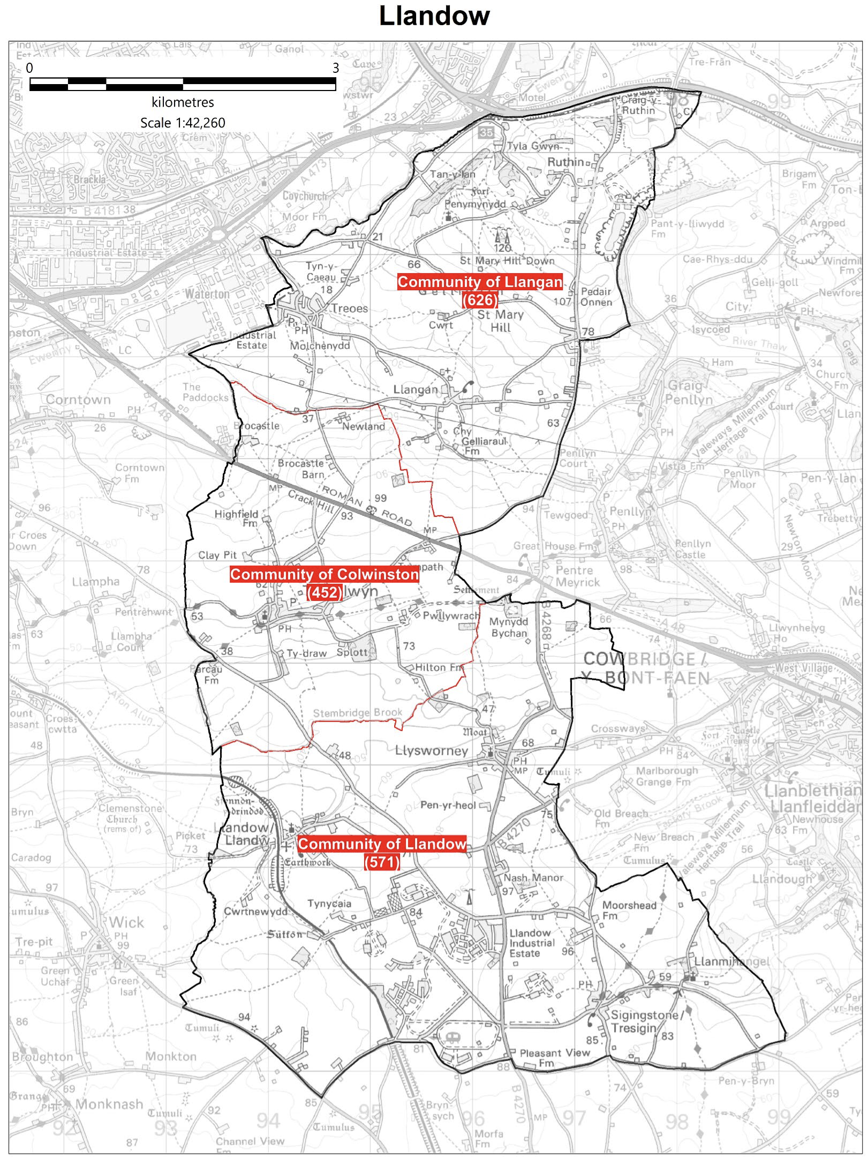

Cllr. Christine Cave email: cacave@valeofglamorgan.gov.uk
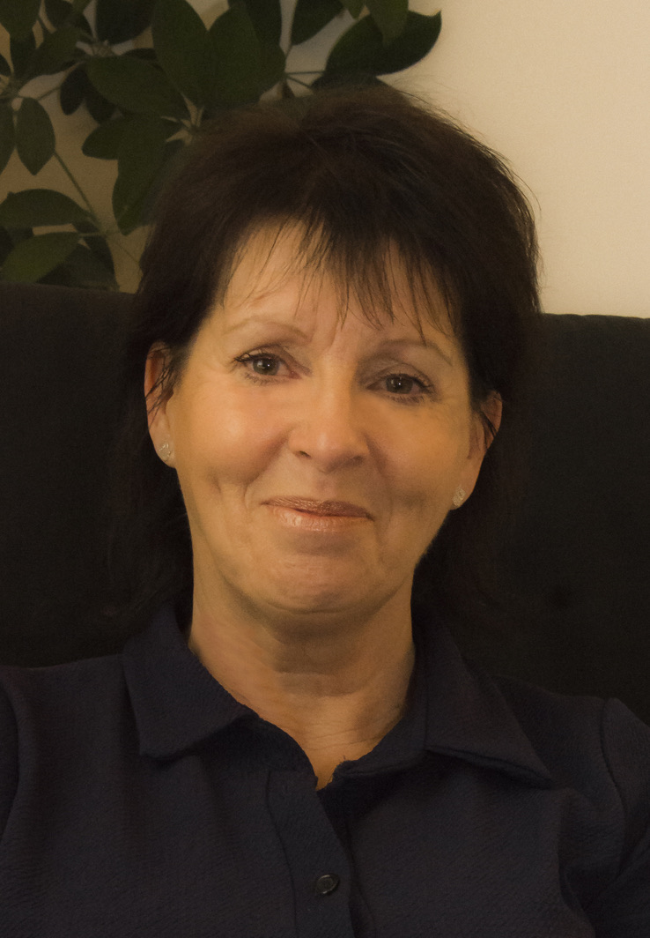
Date: December 2022/January 2023- Report to the Community Councils (CC) in the Llandow Ward: Colwinston; Llandow/, Llysworney, Sigingstone, Sutton and Llangan/Treoes and St Mary Hill.

Vale of Glamorgan Full Council future meeting date for 2022/23:-

6th March, 2023
24th April, 2023

Special Council Meeting

11th January 2023

Vale of Glamorgan Special Council meeting December 5th 2022

6.05 P.M. - REMOTE MEETING

Agenda

PART 1

1. Apologies for absence.
2. (a) To hear the roll call of Members.
(b) To receive declarations of interest under the Council’s Code of Conduct.
(Note: Members seeking advice on this item are asked to contact the Monitoring Officer at least 48 hours before the meeting.)
3. To approve the minutes of the meetings held on:
(a) 26th September, 2022;
(b) Special Meeting, 9th November, 2022.
4. To receive any announcements from the Mayor, Leader, Members of the Cabinet and the Head of Paid Service and to receive any petitions submitted by Members.
Report of the Chief Executive –
5. Use of the Chief Executive’s Emergency Powers.
6. To consider the following proposal(s) from the Executive in relation to the Council’s Policy Framework and Budget

Item | Date of Meeting | Minute No.
(a) Cardiff and Vale of Glamorgan Market Stability Report 2022. | 6th October, 2022 | C93
(b) Treasury Management Mid Term Report | 17th November, 2022 | C132
(c) The Vale of Glamorgan Community Review. | 17th November, 2022 | C133
(d) Council Tax Reduction Scheme. | 1st December, 2022 | C159

N.B. The reports which are the subject of the references in respect of Agenda Items 6(a) – (d) above have already been circulated to Members with the Cabinet agendas for 6th October, 17th November and 1st December, 2022.
7. To inform the Council of the Use of the Urgent Decision Procedure under Article 15.14 of the Constitution.

Item | Date of Meeting | Minute No.
(a) Draft Vale of Glamorgan Council Annual Self-Assessment 2021/22 | 8th September, 2022 | C63
(b) Amended School and College Transport Policy. | 29thSeptember, 2022 | C76
(c) Proposal to Add St. Richard Gwyn to the Capital Programme. | 29thSeptember, 2022 | C77
(d) Capital Monitoring for the Period 1st April to 31st August 2022. | 6th October, 2022 | C90
(e) Dwr Cymru Welsh Water Consultation on the Drainage and Wastewater Management Plan. | 6th October, 2022 | C95
(f) Final Draft Vale of Glamorgan Council Annual Self-Assessment Report 2021/22. | 20th October, 2022 | C104
(g) Capital Monitoring for the Period 1st April to 30th September, 2022 | 3rd November, 2022 | C119
(h) Consultation on Proposals for Primary Legislation in Relation to Children’s Social Care, Continuing Health Care, Mandatory Reporting and Regulation and Inspection | 3rd November, 2022 | C123
(i) Council Tax Reduction Scheme. | 1st December, 2022 | C159

8. To receive questions and answers pursuant to Section 4.19.2 – 4.19.7 of the Council’s Constitution (i.e. questions on any matter in relation to which the Council has powers or duties or which affects the Vale of Glamorgan).
9. Questions from the public.
1 question has been received.
10. Any items which the Mayor has decided are urgent (Part I).

Cabinet meeting

Members of the Cabinet:
Councillor L. Burnett (Executive Leader and Cabinet Member for Performance and Resources) – Labour Party
Councillor B.E. Brooks (Deputy Leader and Cabinet Member for Sustainable Places) – Labour Party
Councillor R.M. Birch (Cabinet Member for Education, Arts and the Welsh Language) – Labour Party
Councillor M.R. Wilson (Cabinet Member for Neighbourhood and Building Services) Labour Party
Councillor M.R. Wilkinson (Cabinet Member for Public Sector Housing and Tenant Engagement) Labour Party
Councillor E. Williams (Cabinet Member for Social Care and Health) Llantwit First Party
Councillor S. Sivagnanam (Cabinet Member for Community Engagement, Equalities and Regulatory Services) Labour Party
Councillor G. John (Cabinet Member for Leisure, Sport and Well-being) Llantwit First Party

Cabinet meeting Minutes of a hybrid meeting held on:

15TH DECEMBER, 2022 AT 2.00 PM - REMOTE MEETING
AGENDA
1. Apologies for absence.
2. Minutes of the Meeting held on 1st December, 2022.
[View Minute]
3. To receive declarations of interest.
(Note: Members seeking advice on this item are asked to contact the Monitoring Officer at least 48 hours before the meeting).
[View Minute]
Report of Meeting –
4. Corporate Parenting Panel – 17th October, 2022.
[View Minute]
Reports of the Executive Leader and Cabinet Member for Performance and Resources –
5. UK Shared Prosperity Fund.
[View Minute]
6. Council Tax Base: 2023/24.
[View Minute]
7. Cost of Living Support for Food, Warm Spaces and Other Means of Support.
[View Minute]
Report of the Deputy Leader and Cabinet Member for Sustainable Places –
8. A Visitor Levy for Wales – Vale of Glamorgan Council.
[View Minute]
Report of the Cabinet Member for Education, Arts and the Welsh Language –
9. School Admission Arrangements 2024/25.
[View Minute]
Reports of the Cabinet Member for Community Engagement, Equalities and Regulatory Services –
10. The Vale of Glamorgan Replacement Local Development Plan 2021 – 2036: Integrated Sustainability Appraisal Scoping Report - Report of Consultation.
[View Minute]

Current Consultations Vale of Glamorgan Council
Help the council to decide their priorities for 2023/24
We're consulting on what we need to focus on for the future. To do this, we need to look at what we achieved and what we could have done differently. You can let us know whether you agree with our progress, commitments and objectives by completing our short survey.
Our Priorities for 2023/24 consultation
Review of statues, monuments, street and building names and suggestions for future recognition and commemoration.
The Council is proactively reviewing all statues and commemorations in the Vale of Glamorgan. This work will ensure statues and commemorations on public land, as well as the names of streets and buildings are representative of local people’s values and those of a modern, inclusive Council. If you have seen a commemoration that you think should be reviewed to ensure it is appropriate, please complete our online form. Please ensure you include the location and reason for review.
Your Penarth Esplanade
Your Penarth Esplanade - A thriving seafront for all
More than £500,000 has been invested in Penarth Pier Pavilion and the Esplanade in the last two years. The Vale of Glamorgan Council is now speaking to local residents, businesses, and community groups about how to further improve Penarth seafront and the surrounding area.
Recognition and Commemoration
New Housing Development - Requirements for School Places
There are a number of new housing developments in the Vale. We are asking residents who are moving to new housing developments to let us know their requirements for school places. Please read the letter below and respond to the online survey

Local Matters
- Rural Road Traffic issues/road safety: identification of local road safety hotspots to inform the way forward – Consultation with council and CC’s ongoing
- Llandow waste recycling centre – issues raised at full council in December 2022 - ongoing
- Colwinston – Coffin stile –- Enforcement action approved by the planning committee at their November 2022 meeting.
- Colwinston – Adoption of the Vines - drainage approved and the Vale of Glamorgan should proceed with adoption - ongoing
- Colwinston – Active travel plan awaiting response from legal team within the council following support from the CC
- Colwinston – Twmpath Track Obstruction - ongoing
- Colwinston - Parliamentary Boundary Review – ongoing
- Colwinston - Trees at Sycamore Tree Inn – awaiting information
- Colwinston – Damaged Light Box, St Michaels Close, reported to the highways team – ongoing
- Colwinston – St. David’s Church in Wales School, meeting to be arranged to gain an understanding of ongoing issues
- Llandow – weight restriction signage and road layout Nash Junction/Llysworney speeding issues Speedwatch issues has seen Alun Cairns MP write on several occasions now directly to the Chief Constable of South Wales – ongoing – written to VoG regarding repair/replacement sign Nash Junction.
- Llandow – Llysworney Community Association meeting to discuss planning application for 10 flats – ongoing.
- Llandow – Sigingstone pre planning consultation, matters raised with local AM and others – application will come to the planning committee – new planning application made – ongoing.
- Llandow – Sigingstone Environmental Health officer contacted in relation to the activities at the go-kart track – Llandow CC monitoring the situation – ongoing
- Llandow – Broadband and telephone outage issues – ongoing
- Llandow – fly tipping during Christmas on the highway verge close to the recycling centre reported
- Llandow – Pot hole top of East View on the bend by the farm gate - reported
- Llangan – Parc Newydd – ongoing
- Llangan – matters in respect of missing signaged raised with VoG officers
- Llangan – Potential noise problems reported by CC members – ongoing
- Llangan – Solar farm pre planning consultation Troeos – ongoing

Schedule of meetings for January 2023 - All Meetings commence at 6.00 p.m. and will be held virtually unless otherwise stated:

Council | 11 Jan (Special) | Early Retirement/Redundancy (4.00 p.m.) | 26 Jan
Annual Meeting |  | Licensing - Public Protection  (10.00 a.m.) | 10 Jan
Cabinet (2.00 p.m.)  [View Live Stream - 5 January] | 9 Jan;  23 Jan  5 Jan;  19 Jan | Licensing - Statutory
Scrutiny (Corporate Performance and Resources) | 18 Jan | Licensing Sub (10.00 a.m.) | 9 Jan
Scrutiny (Environment and Regeneration) | 17 Jan | Planning (4.00 p.m.) | 25 Jan
Scrutiny (Healthy Living and Social Care) (5.00 p.m.) | 10 Jan | Public Rights of Way (10.00 a.m.) | 24 Jan
Scrutiny (Homes and Safe Communities) | 9 Jan  11 Jan | Senior Management Appointment | 20 Jan;  24 Jan
Scrutiny (Learning and Culture) (2.00 p.m.) | 12 Jan  13 Jan | Standards (10.00 a.m.) | 26 Jan
Appeals |  | Trust
Goverance and Audit (4.00 p.m.) | 23 Jan  (Extraordinary) | Vale of Glamorgan Local Access Forum
Community Liaison | 19 Jan | Voluntary Sector Joint Liaison | 23 Jan
Democratic Services (4.00 p.m.) |  | Welsh Church Act Estate (4.00 p.m.) | 16 Jan
Investigating |  | Shared Regulatory Services Joint Committee

